Successful careers know no limits
Personnel company Orizon and ski star Ivica Kostelic seal their partnership
- The 39-year-old Croatian becomes Orizon’s brand ambassador
- Exceptional career: World Champion, Olympic medals and World Cup victories
- Orizon strengthens its sport sponsoring commitment
Augsburg, XX December 2018—The Croatian ski racer Ivica Kostelic now supports Orizon’s commitment to skiing in his new role as the brand’s ambassador. The 39-year-old ex-professional sportsman, who for example won four Olympic silver medals, embodies an enormous commitment and willingness to perform and repeatedly proved that setbacks could not throw him off track. Over the upcoming twelve months, Orizon’s and Kostelic’s joint campaigns in skiing will be present in the media. The partnership was brokered by the global sport rights agency Lagardère Sports, while creation and execution of the partnership activation are the responsibility of Munich-based sports marketing agency Rapid Peaks.
“We are particularly pleased to have won such a prominent supporter of our commitment to skiing,” Dr. Dieter Traub, CEO of Orizon enthuses over the new partnership. “Determined, dedicated, successful across national borders, whilst always being pleasant and down to earth—that is what Ivica Kostelic stands for like no other. These are the traits that ultimately also count in the professional life. That is why he fits our company so perfectly. Orizon also has many employees who own a passport from a European country. Sports once again demonstrates how Europe continues to grow together.”
Together, a communication concept as well as content for both social media and an out-of-home campaign were created for German and Croatian markets. In this concept, Ivica Kostelic will be positioned as an intermediary between the two cultures. “Ivica is a unique testimonial and perfect fit to introduce the Croatian audience to Orizon’s services”, states Nenad Miljkovic, Managing Director at Rapid Peaks. “He’s also a great actor, so we were able to create content for the whole winter sports season in just one day.”
Orizon is increasing its involvement significantly in the 2018/2019 winter sports season in comparison to the previous year. This includes the sponsoring of the German Alpine Ski World Cup in Garmisch-Partenkirchen, Oberstdorf and Willingen (Germany) as well as of the popular alpine ski race in Zagreb (Croatia)—the birthplace of Ivica Kostelic—at the beginning of January 2019.
Sports star with unusual career
In a country without noteworthy mountains for alpine skiing and which is not known as a country of snow, Ante Kostelic—father and trainer of Ivica—used unconventional methods at first. Example: Ivica and his younger sister Janica, who became a world star in skiing as well, had to spend nights in a tent or climb up ski slopes on foot. But this hard training workload should be rewarded: with four Olympic silver medals, a world championship title in slalom, the overall World Cup title, five victories in World Cup disciplines and the award as Croatia’s athlete of the year 2002, 2003, 2009, 2010 and 2011, Ivica Kostelic is one of the significant ski racers of the 2000s and 2010s. Despite many injuries, including four ruptures of the cruciate ligament, the Croatian stormed back to the world’s elite. In February 2017, he eventually resigned from competitive sports. Currently, Kostelic commits himself as trainer adviser of the Croatian Ski Association. In the summer months, he often satisfies his second passion – sailing.

Preview of image

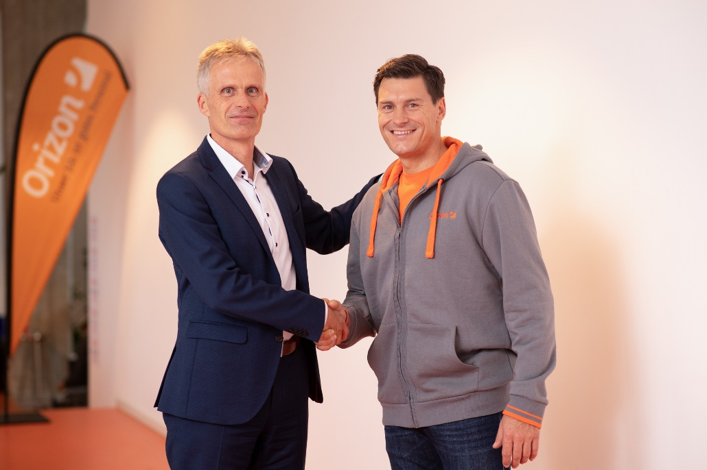

Caption: Dr. Dieter Traub, CEO of Orizon, welcomes Ivica Kostelic as new ambassador of the company
Image rights: Orizon GmbH

Orizon GmbH
The personnel company Orizon offers an extensive range of HR services, including personnel secondment and placement as well as the implementation of complex staffing projects. Orizon covers most professional fields with technical, industrial and commercial staff and executives. Thanks to this strategy, the company is among the market leaders for Germany’s medium-sized enterprises. Since 2017, Orizon has been part of the Japanese Outsourcing Inc., one of the leading consortiums in the staffing service segment.
With around 7 500 employees, approx. 100 offices throughout Germany and a turnover of €295 million in 2017, according to the Lünendonk list Orizon is on rank 9 among Germany’s top HR service providers. In 2018, the German weekly business news magazine “WirtschaftsWoche” named Orizon “Best medium-sized service provider”.
More information on the company is available at https://www.orizon.de

More information for editors
Company: Orizon GmbH press department | Großer Burstah 23 | 20457 Hamburg |
E-mail: presse@orizon.de

Agency: Accente BizzComm GmbH | Dr. Martina Neunecker | Tel. +49 611 / 40 80 619 |
E-mail: martina.neunecker@accente.de

